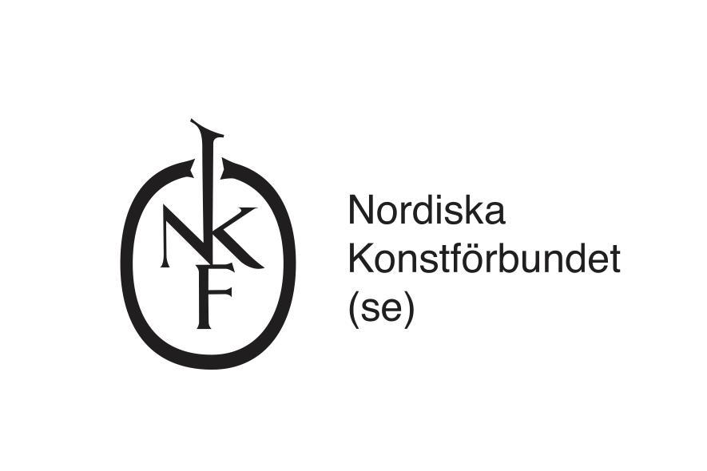

Application form for a residency at The Nordic Art Association’s (NKF) guest studio, 2024

To be completed and sent to application@nkf.se at the latest Friday 13 October, 23:59
Applications submitted after this date will not be accepted

Organisation/institution/person applying:
Contact person:
Full address:
Telephone to contact person:
E-mail:
Website:

Project name:

Name of the guest (artist/curator etc.):

Motivation (max 2000 characters)
Describe how NKF’s guest studio will be used and why the residency is important for the project, guest and the applicant

Dissemination (max 1000 characters) (a public dissemination is supported and encouraged but not required)
Describe how the results of the residency are disseminated. NKF encourages a public presentation or a sharing with a local audience in Stockholm through events such as screenings, talks, open studios or exhibitions in collaboration with other institutions. Public activities in the guest studio are welcome.

Please also include a CV (max 2 pages) of the proposed guest

Residency periods:
Residencies are divided into ten residency periods. Please select your first choice followed by a second and third choice. Please also state if there is additional flexibility. NKF does its best to facilitate successful applicants their preferred dates but will in some cases suggest alternative dates.

First choice:
Second choice:
Third choice:

If a project requires a longer or shorter stay other than the suggested residency period please state that here and include preferred alternative residency dates:

Period 1: 9 januari - 5 februari

Period 2: 13 februari - 11 mars

Period 3: 9 mars - 15 april

Period 4: 23 april - 20 maj

Period 5: 28 maj - 24 juni

Period 6: 2 juli - 29 juli

Period 7: 5 augusti - 2 september

Period 8: 10 september - 7 oktober

Period 9: 15 oktober - 11 november

Period 10: 19 november - 16 december

Other information:

Would you like to sign up to NKF’s newsletter:

