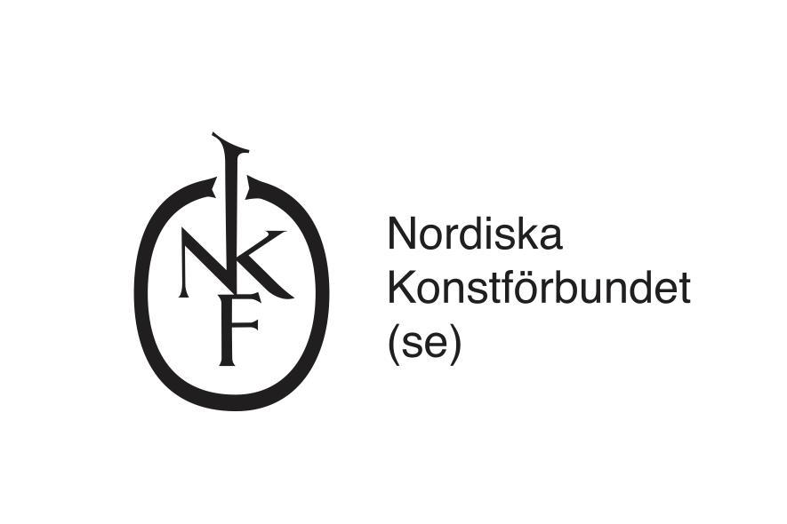

**Application form for a residency at Hangar (Barcelona) in collaboration with The Nordic Art Association’s (NKF), in November 2025**

To be completed and sent to [application@nkf.se](mailto:application@nkf.se) at the latest Sunday 12 January, 23:59

Applications submitted after this date will not be accepted

**Name**:

**Postal address:**

**Telephone:**

**E-mail:**

**Website:**

**Motivation** (max 2000 characters)

*Describe how you intend to use the time and facilities at Hangar to develop your practice. Explain why the residency is relevant for you and, if applicable, the project you intend to work on during your stay.*

**Please also include a CV (max 2 pages)**

**Feel free to also include a portfolio showcasing previous work (max 5 pages)**

**Other information:**

**Would you like to sign up to NKF’s newsletter:**