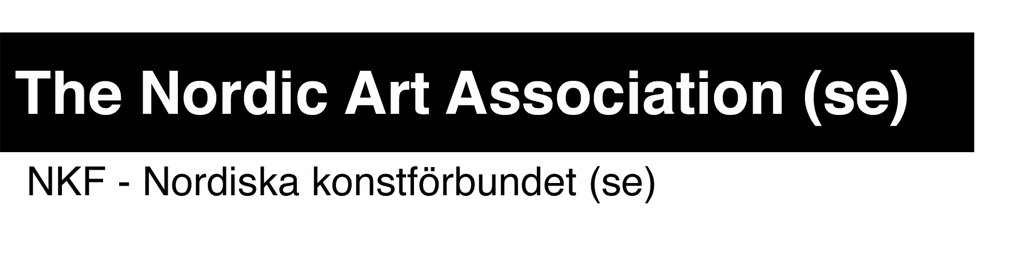
Application form for the Nordic Guest Studio, Malongen.

To be sent in by 2015-09-30 at the latest
Organisation:
Address:
E-mail:
Web address:
Contact person:
Title contact person:
E-mail to contact person:
Telephone to contact person
Project name:
Name of artist:
Period starts at: yy/mm/dd
Period ends at: yy/mm/dd
This period is flexible (yes or no) :
(a flexible period means that your dates are not confirmed and may be subject to change)

Project description:

(maximum 3000 characters, make sure to describe how the Nordic Guest Studio will be used and why the residence is important for the artist and the organisation)

Dissemination:
(how will the results of the residency period be disseminated to a public audience in Stockholm, exhibitions, screenings, talks, open studio etc etc…Open activities in the studio are welcome! Maximum 1000 characters)

URL:s where works and information about the artist can be found:

Other information:

Attachments:
CV of the artist (mandatory)

