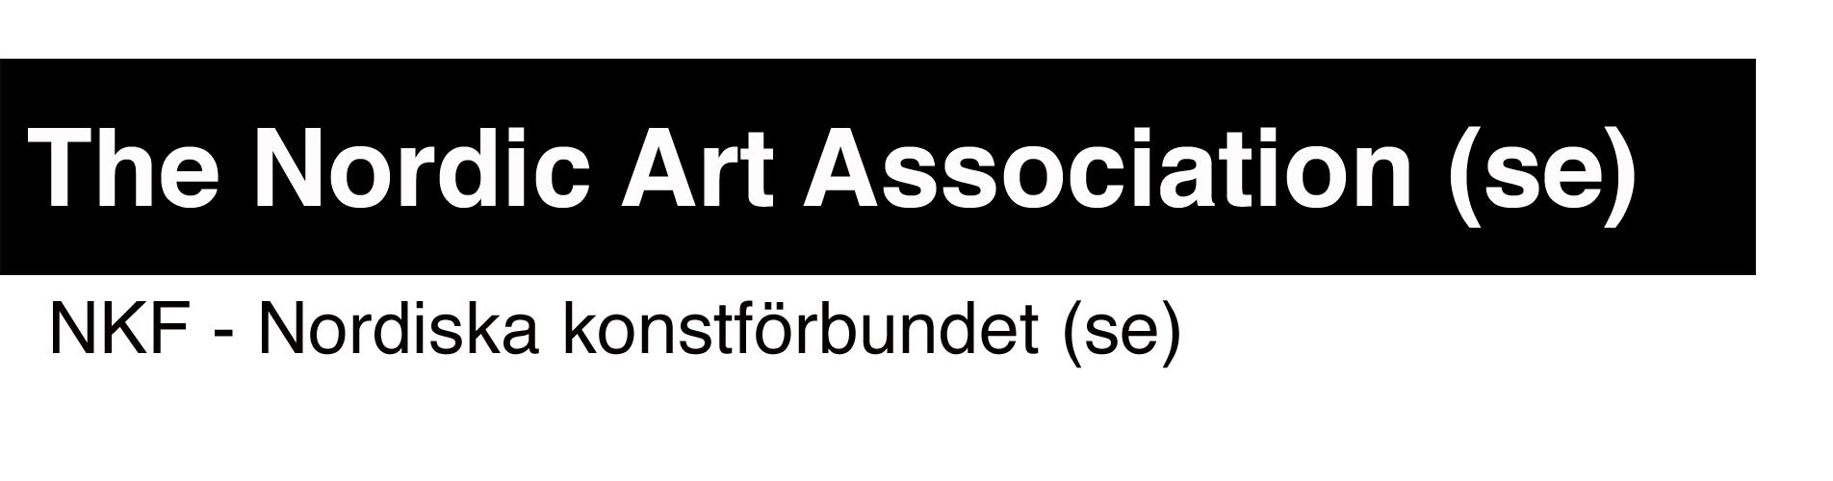
Application form: the Nordic Guest Studio 2023

To be completed and sent in to application@nkf.se by 2022-09-30 as the latest

Organisation/institution/person:
Address:
E-mail:
Website:
Contact person:
Title of contact person:
Email to contact person:
Telephone to contact person:
Project name:
Name of the guest:
Preferred dates for residency stay begins: yy/mm/dd
Preferred dates for residency stay ends: yy/mm/dd
Alternative start date:
Alternative end date:
Preferred periods are flexible (yes or no):
(If flexible, NKF may suggest other dates.)

Project description (maximum 3000 characters)
Describe how the Nordic Guest Studio will be used and why the residency stay is important for the project, guest and the applicant.

Dissemination (maximum 1000 characters)
Describe how the results of the residency stay are disseminated to a public audience in Stockholm through such events as exhibitions, screenings, talks, open studio etc. (Public activities in the Nordic Guest Studio are welcome!

URL:s where works and information about the guest can be found:

Attachments:
CV of the guest

Other information:

